# TSWIFTY Token Whitepaper

BETA Feature Notes v0.01

*Not for public release*

All features listed here are not final and may change.

Testers are requested not to share this document.

## Summary

The TSWIFTY token is a token designed to reward users for not selling. Holders can earn an APY (Annual Percentage Yield). If an address sells any tokens they are punished by earning 0% APY for a period of time.

The token is inflationary. This means that new tokens will be minted to pay for the interest.

The token has taxation. This means that for every transaction (sale and purchase) there is a tax applied which is used for different purposes. See the Taxation section of this document.

The token has features which allows the user to earn a higher interest rate in exchange for locking their address from performing any sells for a period of time. If someone wants to unlock their address they will need to pay an additional tax.

The TSWIFTY token has been designed to be traded on the Binance Smart Chain network and on the Pancakeswap Decentralised Exchange.

The initial inception of the token is designed to allow SwiftDemand token holders a way to transfer their tokens to a blockchain technology.

## Terminology

* Liquidity Pool
  + Decentralised Exchanges (DEX) require a liquidity pool. A liquidity pool is a supply of TSWIFTY and a supply of another token (example: BNB). This allows you to buy and sell the token. When you want to sell TSWIFTY the DEX will give you BNB from the liquidity pool. When you want to buy TSWIFTY with BNB, the DEX will give you TSWIFTY from the liquidity pool.
* BUY
  + A buy is when you receive TSWIFTY from a Decentralised Exchange (DEX) such as Pancakeswap in exchange for another token such as BNB.
  + For the purposes of Taxation receiving TSWIFTY from another address which is not a decentralised exchange is NOT considered a buy.
* SELL
  + A sell is when you sell TSWIFTY to a Decentralised Exchange (DEX) such as Pancakeswap in exchange for another token such as BNB.
  + A sell is when you send TSWIFTY to another address.

## Token Distribution

The initial total supply will be 10 Billion Tokens.

* 0.5% Swift Demand Airdrop – Verified Swift Demand users can register for an airdrop via Telegram. The airdrop will be distributed to token holders once the project is launched. Users can receive a maximum of 50,000 tokens each. If less than 0.5% is claimed then the remaining balance will be burned which reduces the total supply. The exact method of registration, verification and transfer has not been decided yet, but doesn’t affect the tokens functionality.
* 15% Swift Demand token transfer. Verified Swift Demand users can transfer their Swift Demand tokens to the blockchain. The tokens transferred will be distributed once the project has been launched. If less than 25% is transferred then the remaining balance will be burned which reduces the total supply. The exact method of registration, verification and transfer has not been decided yet, but doesn’t affect the tokens functionality.
* 75% Presale allowance. A presale will be run by a 3rd party (example: Dxsale.network or bifrost.market). This allowance will be used for the Presale and to generate the initial liquidity pool on Pancakeswap. Any tokens allocated to the presale which are not sold will be burned.   
  70% of the funds generated from the Presale will be added to the liquidity pool and locked for 10 years. This means the funds cannot be accessed by the development team and is only used to supply liquidity to the market, allowing people to buy and sell.   
  30% of the funds will be used for marketing post launch.
* 9.5% Team Funds. This allowance will be permanently locked from being sold. The team will only earn a reduced 10% APY and can withdraw this generated interest as necessary.

## Features

### Taxation

Every buy and sell transaction is taxed 3%.

* Breakdown:
  + Burn 1% - Reduces the total token supply to offset some inflation.
  + Dev 1% - Goes to the development team. Used for marketing or general development costs of running the project.
  + Liquidity 1% - Added to the contract address which can be used later to increase the liquidity pool. See the liquidity function description in this document.

### Earning Interest

Every address holding TSWIFTY is eligible for earning interest.

Interest is calculated to the lowest whole minute. 1.99 minutes will earn interest for 1 minute.

Interest will start being earned immediately after an address receives its first TSWIFTY.

For the purposes of calculation an APY is calculated over 366 days.

#### Sell Penalty Rate – 0%

When an account performs any sell they will earn 0% APY on their account balance for 28 days from the time they made the sale. After 28 days they will earn interest again, however you will be reduced to the standard rate.

#### New Address Rate – 20%

Any address which purchases or receives TSWIFTY for the first time will be given an APY rate of 20%.

#### Swift Demand Transfer Address Rate – 40%

Any address which is part of the Swift Demand token transfer will receive a bonus APY rate of 40%

#### Standard Address Rate – 12%

Any address which has performed a sell in the past will receive the standard rate of 12%. The only way for them to increase their rate is by locking their address as described below.

##### Locked Address Rate – 40%

TSWIFTY holders have the option of locking their address. This prevents their address from sending TSWIFTY tokens for a period of 168 days.

Users who have performed a sell can use the locking feature to restore their interest earning, rather than earning 0% for 28 days, however their account will remain locked for the whole 168 days.

Users have the ability to unlock their accounts, however they will need to pay a 20% early unlock fee on the full balance of their TSWIFTY. See the Unlock function for more details.

### Smart Contract Functions

For the purposes of keeping things simple I will only detail the customized public functions that users of the token need to be concerned about. There are other functions available that only the contract owner can use. There are also public functions that are standard among any ERC20 or BEP20 functions. More can be read about those here <https://github.com/binance-chain/BEPs/blob/master/BEP20.md>

Eventually the TSWIFTY website will support these functions. Until then, you can use the bscscan website by selecting the “Contract” tab and connecting your web3 wallet such as Metamask.

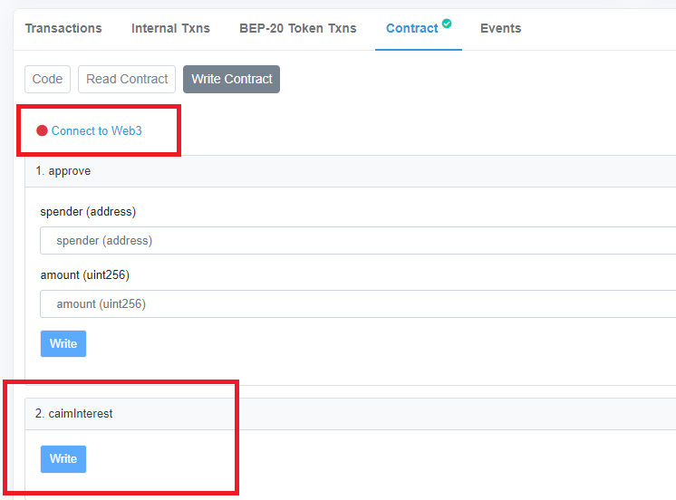

#### claimInterest

By calling this function the contract will calculate all the interest which is due to be claimed and transfer it to your address immediately.

This has been made a manual function for two reasons.

1. Income or Capital Gains Taxation. Depending on where you are resident it may be beneficial for you to claim your interest at a different time.
2. Depending on the users preference they can claim their interest regularly. By doing this they get the additional benefit of creating compounding interest.

#### lockSalesInExchangeForBonusInterest

By calling this function the caller will receive a bonus interest rate of 40% for a period.

In order to receive the bonus rate the address will be prevented from selling TSWIFTY tokens for a period of 168 days.

While an address is locked users can still call the claimInterest function to compound their interest.

While an address is locked users can still receive new tokens and earn interest on the new balance.

Users have the option to unlock their address. See the “payToUnlockAddress” section below.

#### payToUnlockAddress

If a user wants to unlock their address they can use this function.

The unlock fee is 20% of the current TSWIFTY balance. Any unclaimed interest is NOT included in the fee charged and can be claimed later.

If you claim your interest before unlocking your account then this will be included in the fee charged.

After unlocking your account your APY rate will be reduced to the standard 12% rate.

#### isAccountLocked

By sending an address to this function it will return true or false indicating whether or not the address is locked.

#### whenWillAccountUnlock

This returns the number of seconds until the account unlocks. You can convert this number into a readable date and time using this website <https://www.unixtimestamp.com/>

#### generateLiquidityFromContractTokensSupply

1% of every transaction is taken as a liquidity tax and transferred to the contract. See the Taxation section of this document for more details.

The plan for this tax is to periodically convert 50% of it to BNB and add the BNB and the other 50% of TSWIFTY to the liquidity pool.

This function allows anyone to convert the tokens to BNB and automatically add it to the liquidity pool without needing to understand the technicalities behind it.

This function is designed as a safety mechanism in case the dev team become unavailable to add the taxed TSWIFTY to the liquidity pool. The community can step in and use this function to make use of the taxes collected in the contract.